Table of Contents
1. Introduction 2
2. Getting Started 3
3. Updating Personal Information and Uploading a Resume 5
3.1 Resume Upload 5
3.2 Changing Personal Information and Ranking Status 7
4. Adding Qualifications and Skills 8
4.1. Employment History 9
4.2. Skills 10
4.3. Education Qualifications 12
4.4. Additional Qualifications 12
5. Entering Preferences 14
6. Applying for Jobs 15
7. Getting Help 22
8. Glossary 23

Introduction
This user’s guide has been developed for individuals applying for a job at Arctic Slope Regional Corporation. This document serves as a training tool and a reference guide for the main functions of the iRecruitment system that are designed to support the job application process.
This guide contains five sections, which provide a detailed step by step instruction on how to complete and update the job candidate application. Once a candidate profile is set up, this guide can be used as a reference tool for updating applicable information at a later date.
The following sections are provided for general system overview and training purposes:
- Introduction
- Getting Help
- Glossary

The following sections can be used for performing specific functions:
- Getting Started (for first time users)
- Registering
- Setting up a Profile
- Signing in to iRecruitment after Setting Up a Profile
- Applying for Jobs
- Changing Profile Information

Getting Started
- Open Internet Explorer.

- When the internet browser is up, type in the following URL address:
http://office.asrc.com
- Choose “Oracle Self Service”

- Sign on to your Oracle account
Note: This is the same account used for entering Oracle based time reporting. If you do not have an Oracle account, contact the Helpdesk to initiate a request.

- At the Oracle Applications page, click on the Self Service Employee option. Then choose Home on the right side of the Navigator pane (see arrows 1 and 2 in figure 2.0 below).

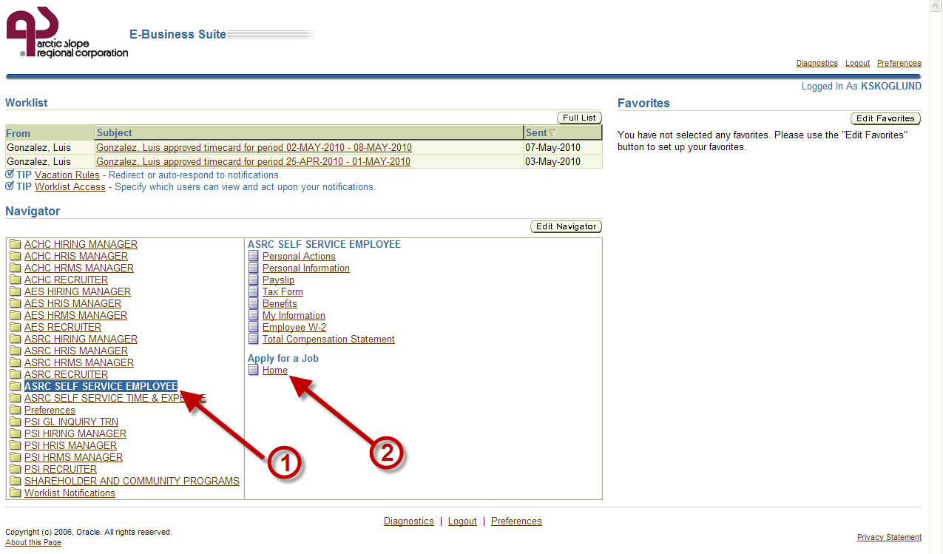
Figure 2.0

- A screen showed in Figure 2.1 will appear.

- First time users should fill out their profile before applying for jobs. If the profile is already established, proceed to section Searching and Applying for Jobs, otherwise click on My Account to set up the profile.

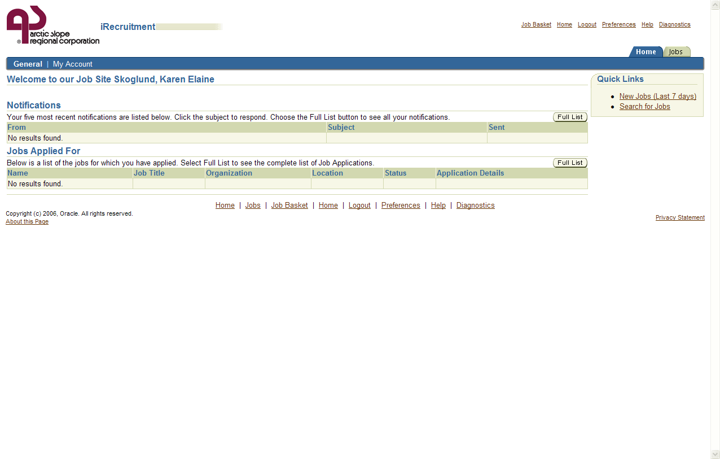
Figure 2.1

Updating Personal Information and Uploading a Resume

3.1 Resume Upload
After My Account is clicked, a screen appears as in figure 3.0 This is where users can enter additional contact information and upload their resumes (Figure 3.0).
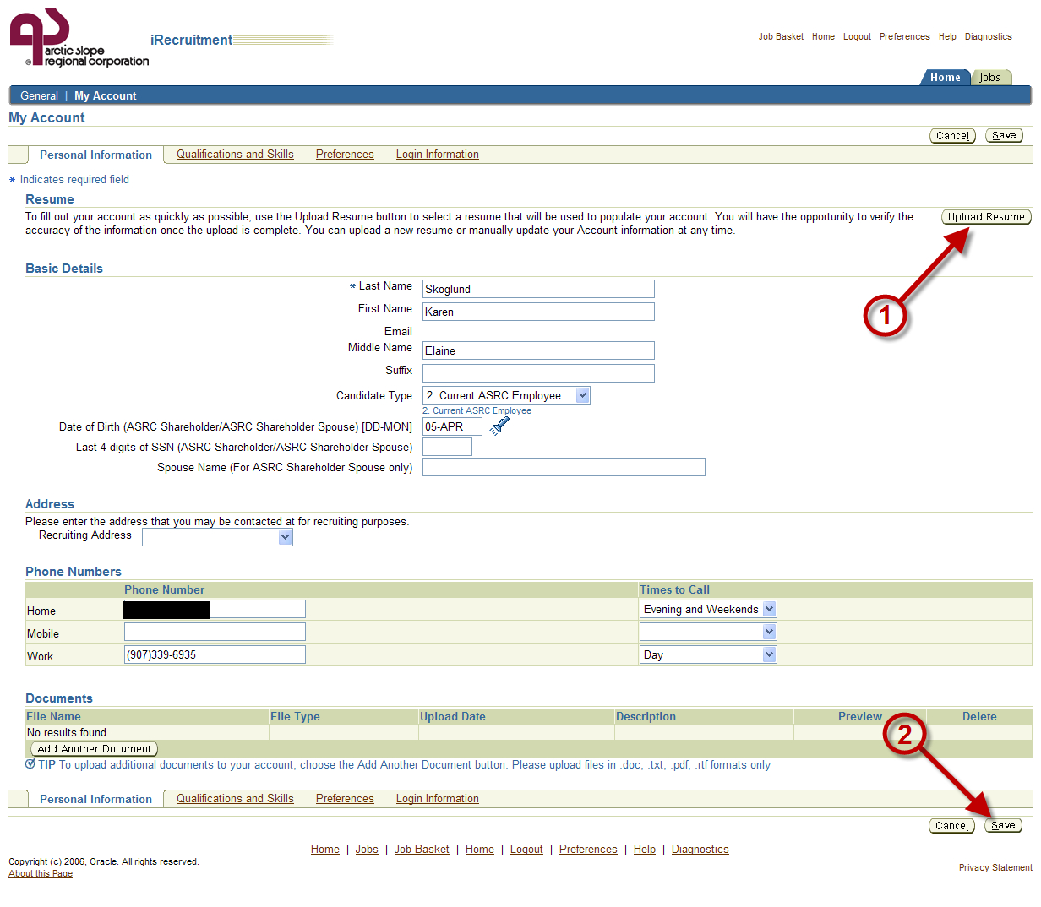
Figure 3.0

If the resume is available and ready to be uploaded, click on the Upload Resume button, and a screen as in Figure 3.1 will appear. Choose the Browse button to find resume.
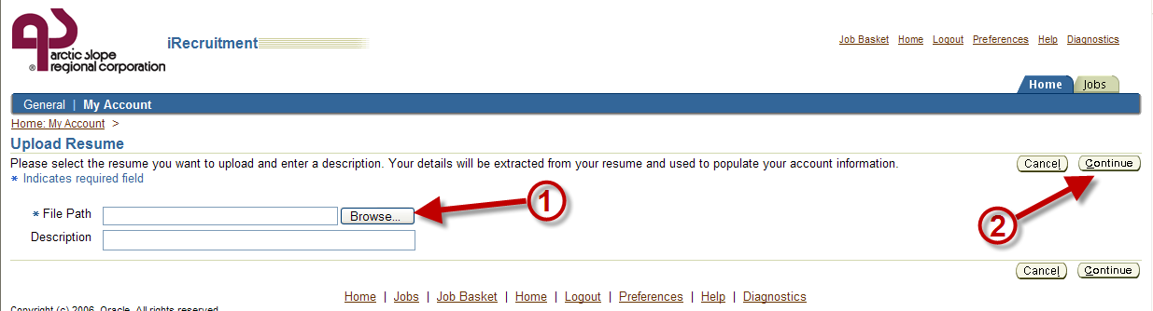
Figure 3.1

Navigate the drive locations to find the resume, highlight the resume, and then click the Open button (Figure 3.2, arrow 1 & 2), then click Continue (Figure 3.1, arrow 2).
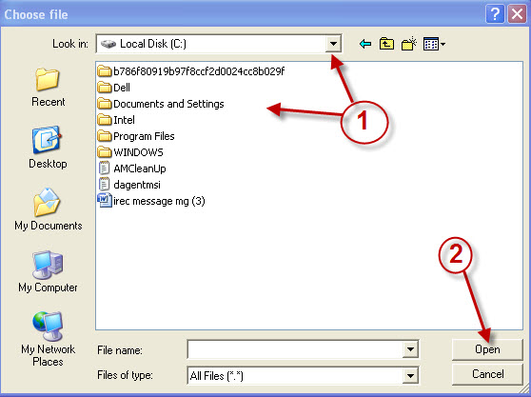
Figure 3.2

Don’t forget to click the Save button before exiting!! (Figure 3.0, arrow 2)

3.2 Changing Personal Information and Ranking Status
Next, fill out all of the applicable fields shown in Figure 3.0. Most of these fields are self explanatory. Fields that require searches are marked with a flashlight icon. The Candidate Type field should have a 1. ASRC Shareholder or a 2. Current ASRC Employee.
If you are a Shareholder, make sure you fill in the date of birth field manually or click on the flashlight symbol to pick a date from the list (Figure 4.5, arrow 1).
Figure 4.4
A small window will pop up. Click on the Go button (Figure 3.3, arrow 1).
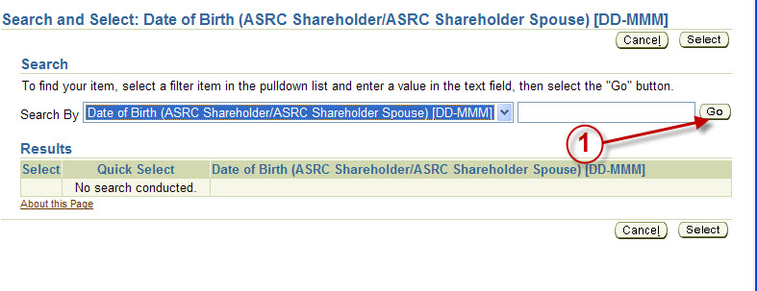
Figure 3.3

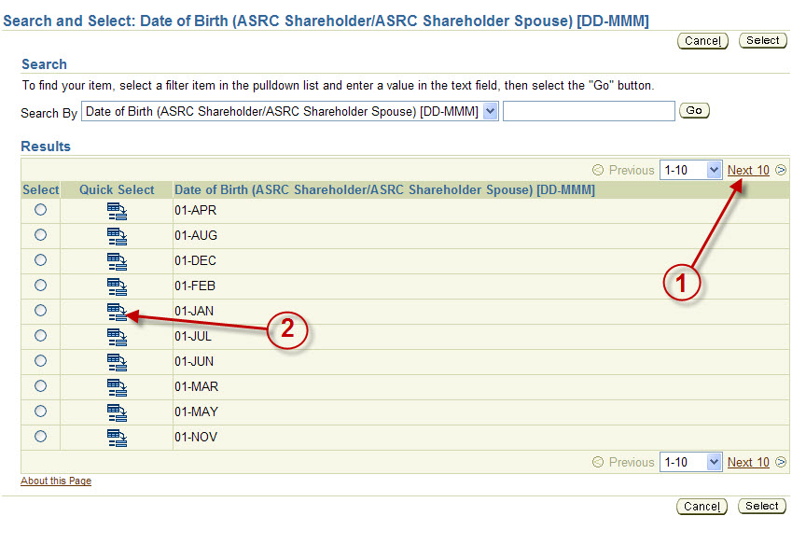
Figure 3.4
Click on Next 10 to move through the list to find the appropriate date and then click on the Quick Select button to choose that date. (Figure 3.4, arrows 1 & 2)
This will bring you back to the screen shown in Figure 3.0. Fill out the spouses’ name (only if spouse is the ASRC shareholder) and continue filling out the rest of the fields on the screen, then click Save.

Adding Qualifications and Skills
Note: iRecruitment uses qualifications and skills to match job vacancy requirements with potential candidates to fill that job.
When at the My Account area, click on the Qualifications and Skills tab. This is where candidates’ qualifications and skills will be entered. It is essential that every possible skill listed in the system that applies to the applicant is included in the profile. The list is the same list of skills, degrees, and certifications that the hiring manager at Arctic Slope Regional Corporation will be choosing from.
The system will use this information to match open job vacancy requirements with viable candidates in the profile database.
Applicants should be very thorough when filling out information on the screen for Adding Qualification and Skills. There are four main sections on the screen:
- Employment History
- Skills
- Education Qualifications
- Additional Qualifications

These are the areas that employers will examine to determine which candidate is the most qualified for the open position.

Employment History
To fill out the Employment History page, click on the Add Employer button (Figure 4.1, arrow 1) and the screen will display the fields as shown in Figure 4.2.
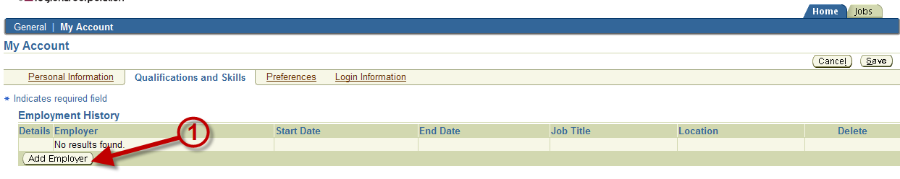
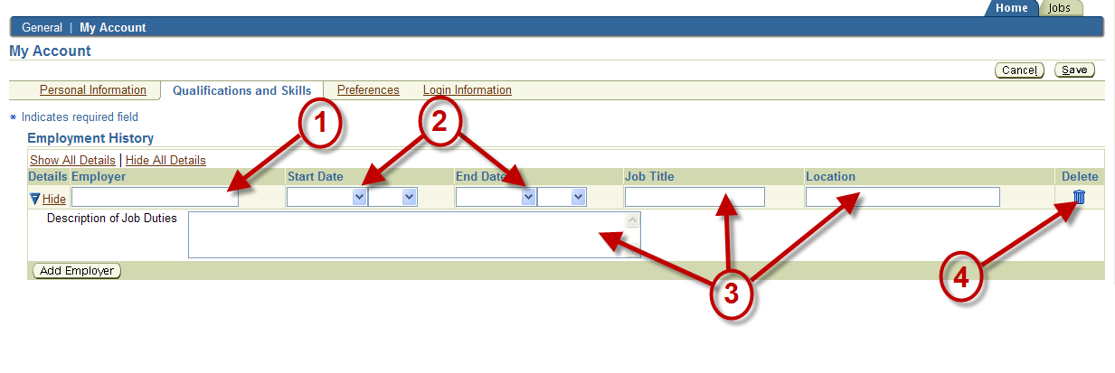
Figure 4.1
Figure 4.2
Also, notice that if you decide not to include this line, you can delete a line of information at any time simply by clicking on the trash can icon located to the right, on the same row (Figure 4.2, arrow 4).

Type the name of the company (see Figure 4.2, arrow 1), use the pull-down menus to designate employment dates (arrow 2), type in the job title, location, and a good description of the job duties performed while on the job (arrow 3).
For additional employment history information, click the Add Employer button (Figure 4.1, arrow 1) and fill in the information. Continue adding employers and filling in information until all employment history is accounted for.

Skills
The next section of this page is the skills area where applicants enter their skills information. Start by clicking on the Add Another Skill button (Figure 4.3, arrow 1)
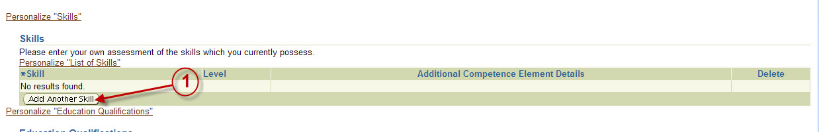
Figure 4.3

And you will get a screen shown in Figure 4.4.

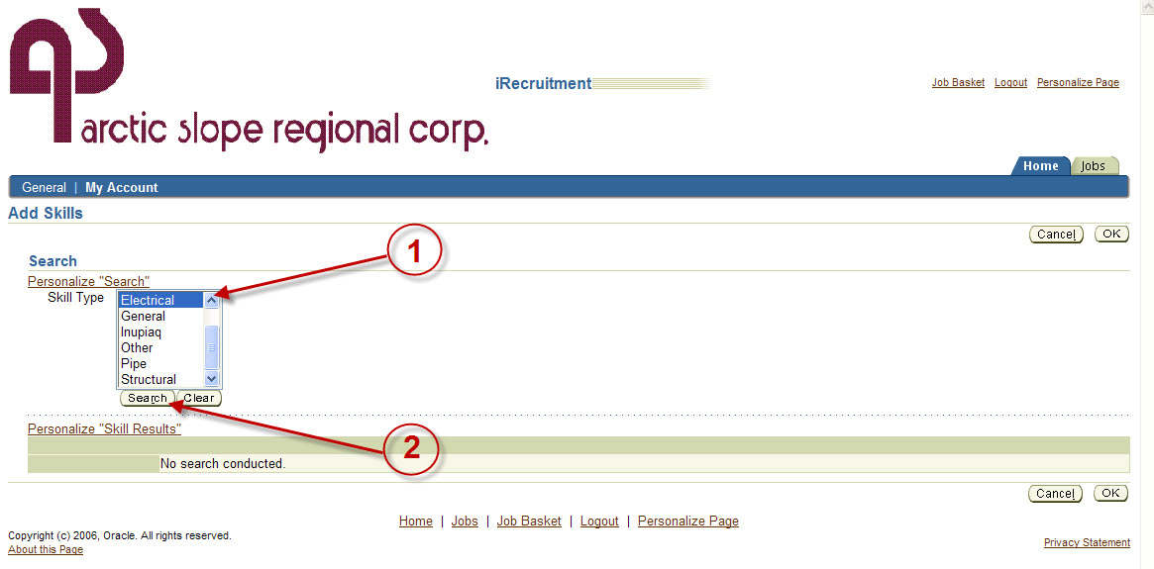
Figure 4.4
Tip: To bring up several skill categories at once, hold down the CTRL key and select multiple skill types.
Click on the Search button to bring up the entire list of skills for all categories.
Highlight applicable Skill Type and click the Search button. (Figure 4.4, arrows 1 & 2). This action will bring up a listing of the skills. Check what applies (Figure 4.5, arrow 1) and then click OK.
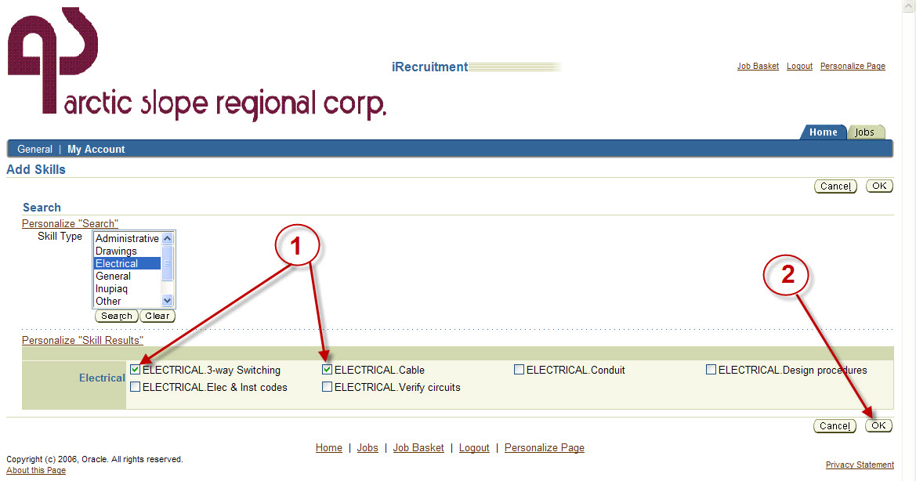
Figure 4.5
The skills checked will be added to the list of skills shown in Figure 4.6. Now set the proficiency level for each skill using the pull down menu (Figure 4.6, arrow 1).
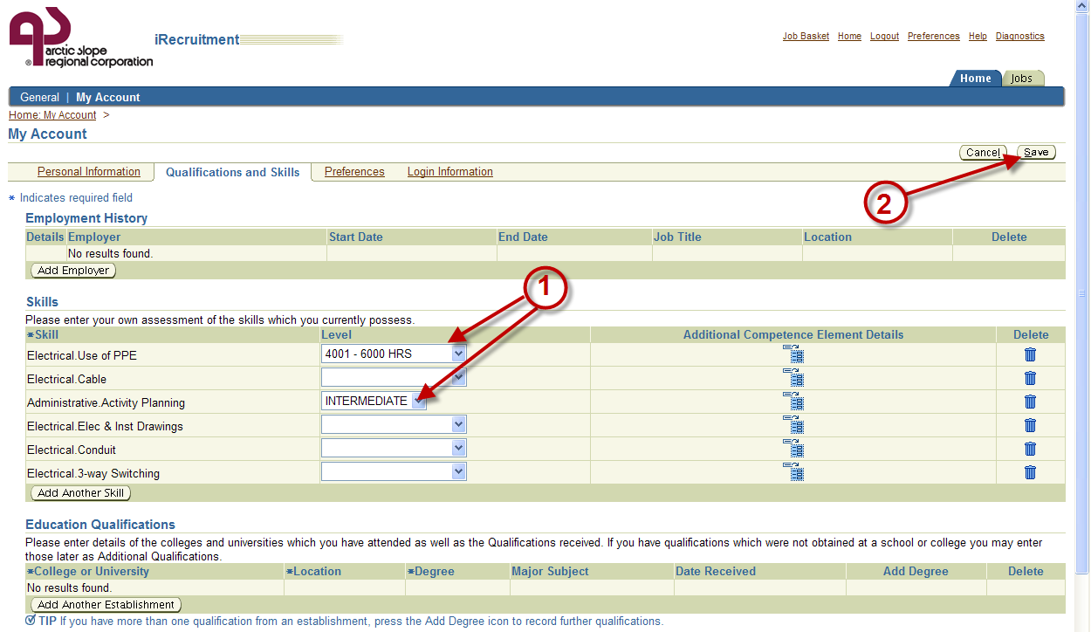
Figure 4.6

After adding applicable skills from the list, it would be a good idea to click the Save button. Move on to the next area of the screen to add Education Qualifications.

Education Qualifications
Click on the Add Another Establishment button (Figure 4.7, arrow 1) and fields shown in Figure 4.8 will appear.
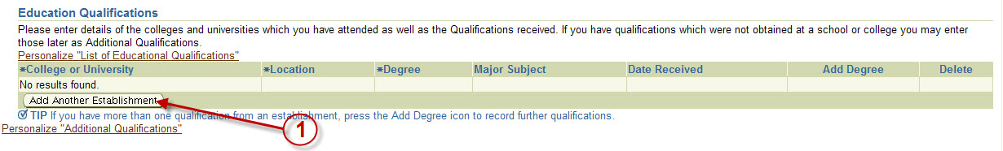
Figure 4.7
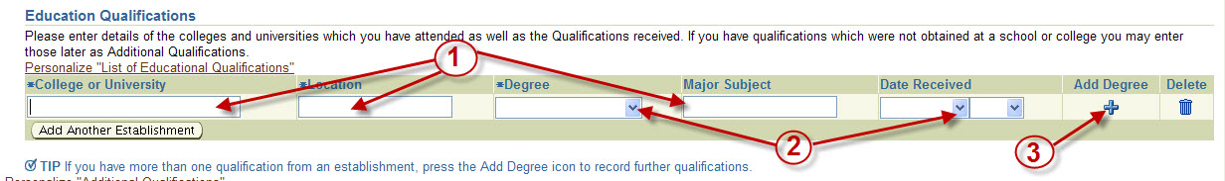
Figure 4.8

Type appropriate information in the fields marked by arrow 1 in Figure 4.8 and use the drop-down menu selections marked by arrow 2. If the applicant has more than one degree from the same establishment, click on the + sign, marked by arrow 3.

Additional Qualifications
Figure 2.11
NOTE: The Additional Qualifications section is where professional certifications are added to the profile such as:
NSTC
CDL levels
Journeyman
Project Management Professional

The fourth and last section for this screen is designated for Additional Qualifications. This is where the applicant may enter specialized or professional certifications.

Click on the Add Another Qualification button (Figure 4.9, arrow 1) and additional fields will become available (Figure 4.10).

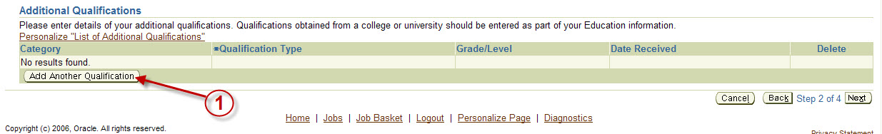
Figure 4.9

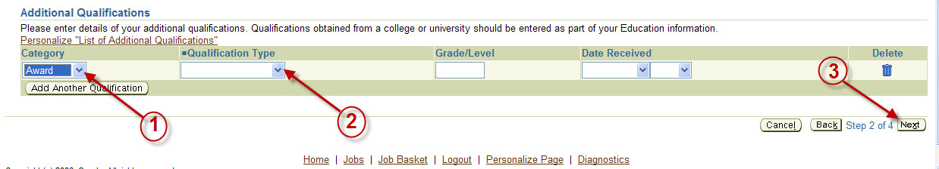

Figure 4.10

If a different category is selected using the Category button (Figure 4.10, arrow 1), the options for Qualification Type will change (Figure 4.10, arrow 2). Fill out all the fields by using the pull down menus and typing in the grade levels if appropriate. Add more licenses to the list by clicking on the Add Another Qualification button, until all professional certifications are added.
This is the final section for this screen. After all of the 4 sections have been filled out for this screen, make sure you click the Save button before logging out.

Entering Preferences
This is where applicants can enter the job type that they would like to apply for. There are no mandatory fields on this screen. Applicants have the option of designating the Job Category or the Location (Figure 5.1).
Notice a section on Email Preferences toward the bottom of the screen in Figure 5.1. Check the appropriate box to receive notifications about job openings that match your skills. (Figure 5.1, arrow 1)

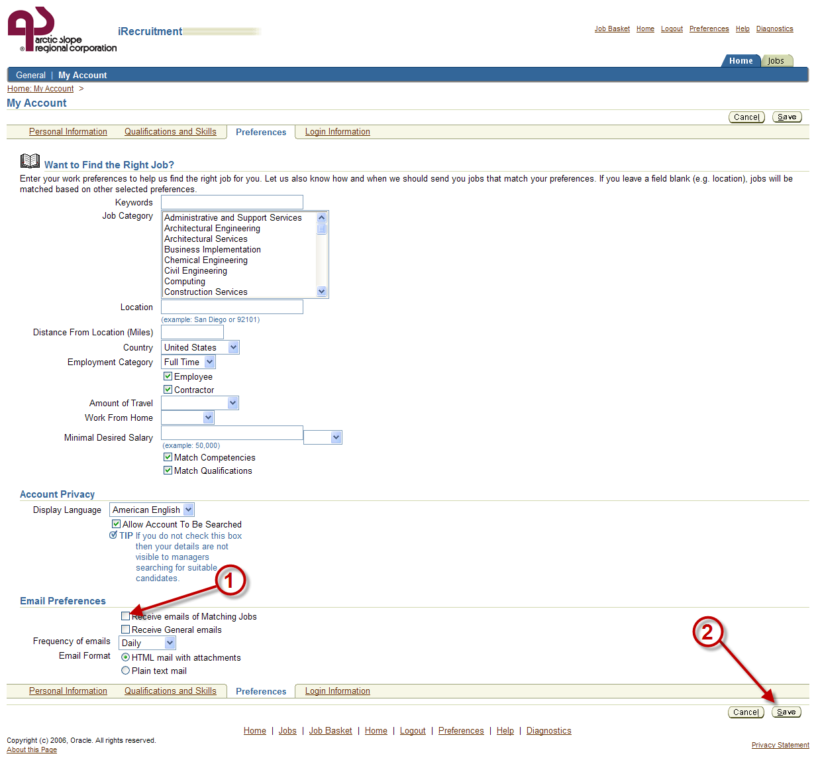
Figure 5.1

Fill out all applicable fields then click the Save button. (Figure 5.1, arrow 2)
The profile has been updated. Applicants can go to the section on Applying for a Job, or click the Save button to logout.

Applying for Jobs
On the home screen, click on Jobs Tab to get to the screen shown in Figure 6.1.
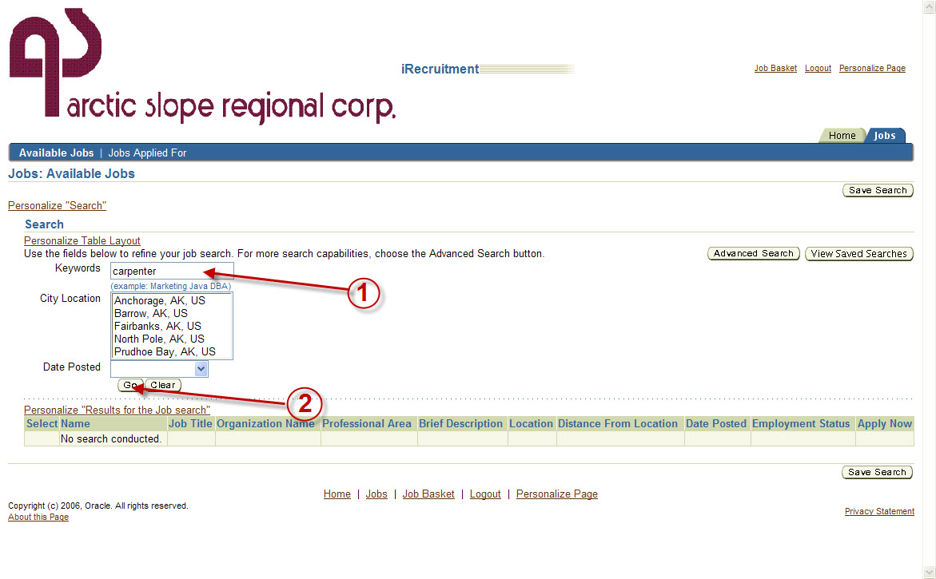
Figure 6.1

Enter a key word to perform a search for specific jobs. For example, to find jobs pertaining to carpentry, type in the word “carpenter” (see Figure 6.1, arrow 1) and click Go.
In this example, the system identified two jobs. To view more details about a job, click on the vacancy link (Figure 6.2, arrow 1). If the first job on the list is desirable, click the Apply Now button on the corresponding line (Figure 6.2, arrow 2).
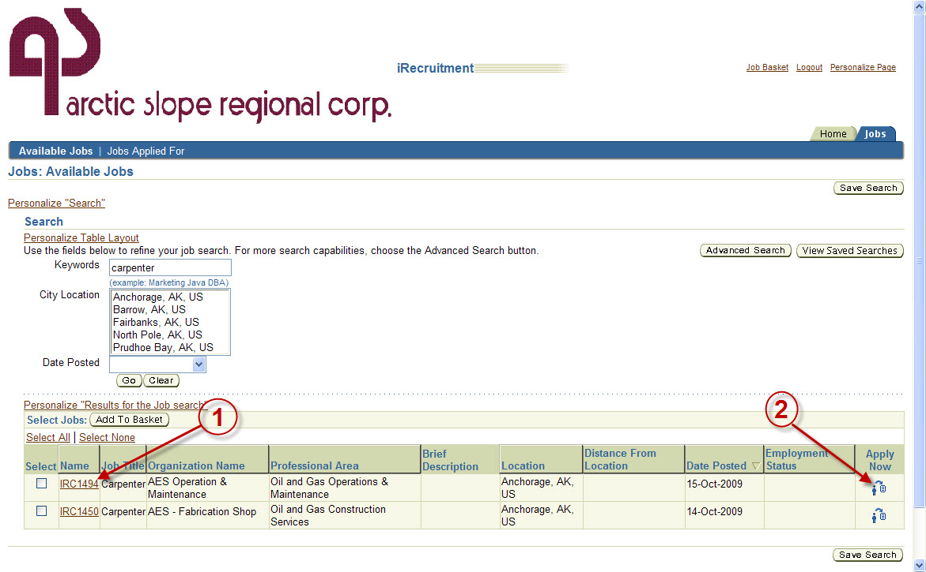
Figure 6.2

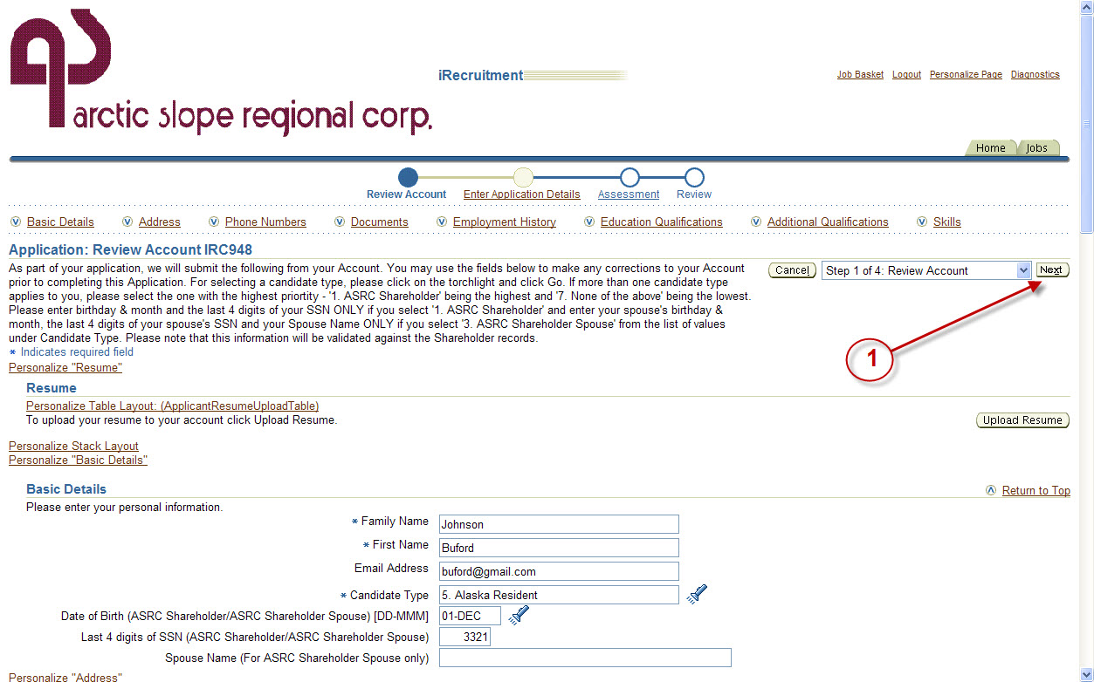
Applicants can review and change their profile information before applying for a job (Figure 6.3). If there are no changes or updates to the profile, click the Next button (Figure 6.3, arrow 1).
Figure 6.3

NOTE: If you apply for a job, the profile information FOR THAT JOB APPLICATION cannot be changed. Changing profile information will apply only for job applications submitted after the change is made.
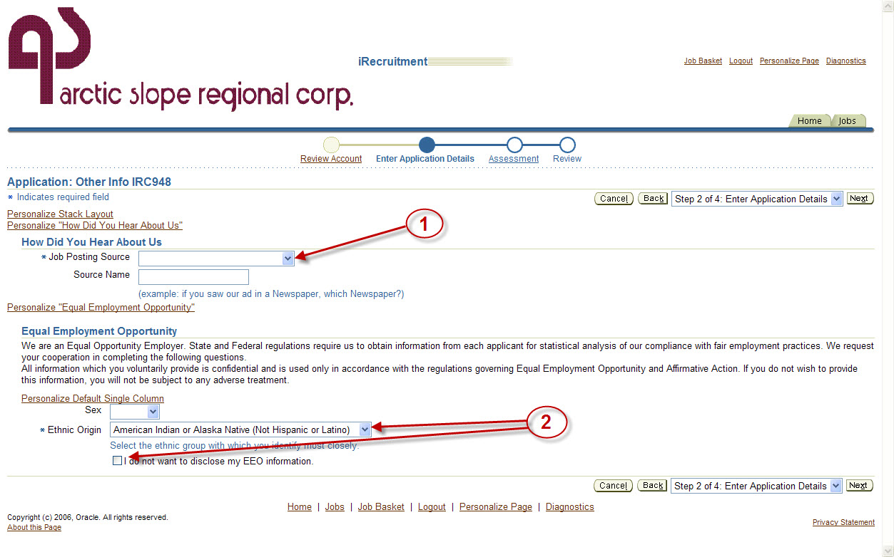
Figure 6.4
Fill out mandatory fields shown in Figure 6.4 before proceeding.
- Use the pull down menu to include the job posting source. (Figure 6.4, arrow 1)
Note: If you heard about the job from a person, please type that person’s name in the Source Name field.

- Applicants may use the pull-down menus to designate their sex and ethnic origin or they may choose not to disclose this information by selecting “I do not want to disclose my EEO information” (Figure 6.4, arrow 2).
Then click the Next button.
Some job postings have pre-qualifying set of questions that all applicants need to complete. If applying for a job with pre-qualifying questions, then something like the following screen in Figure 6.5 will appear:
Note: Very few jobs will have pre-qualifying questions. If the job you are applying for does not, then just click Next to proceed to the Review screen.

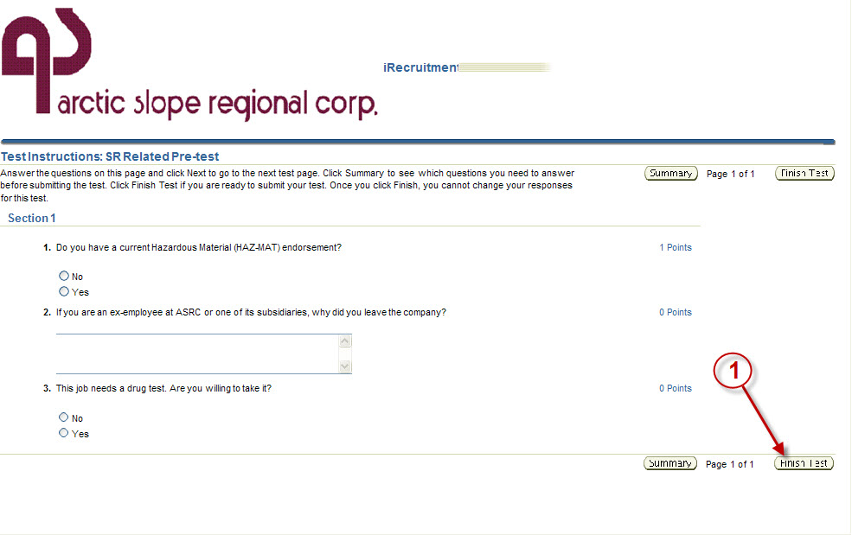
Figure 6.5
This example shows only three questions. Answer the three questions and click the Finish Test button. A screen will come up where you can review the answers or go back to make changes. If satisfied with the answers, click the Submit Test button (Figure 6.6).
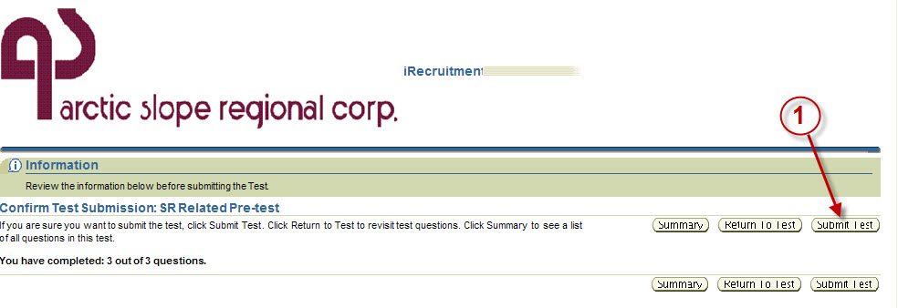

Figure 6.6 1010.6

A final screen will appear where applicants can review their profile information and pre-qualifying question answers. Figure 6.7 on the following page. Click the Finish button when done (Figure 6.7, arrow 1).
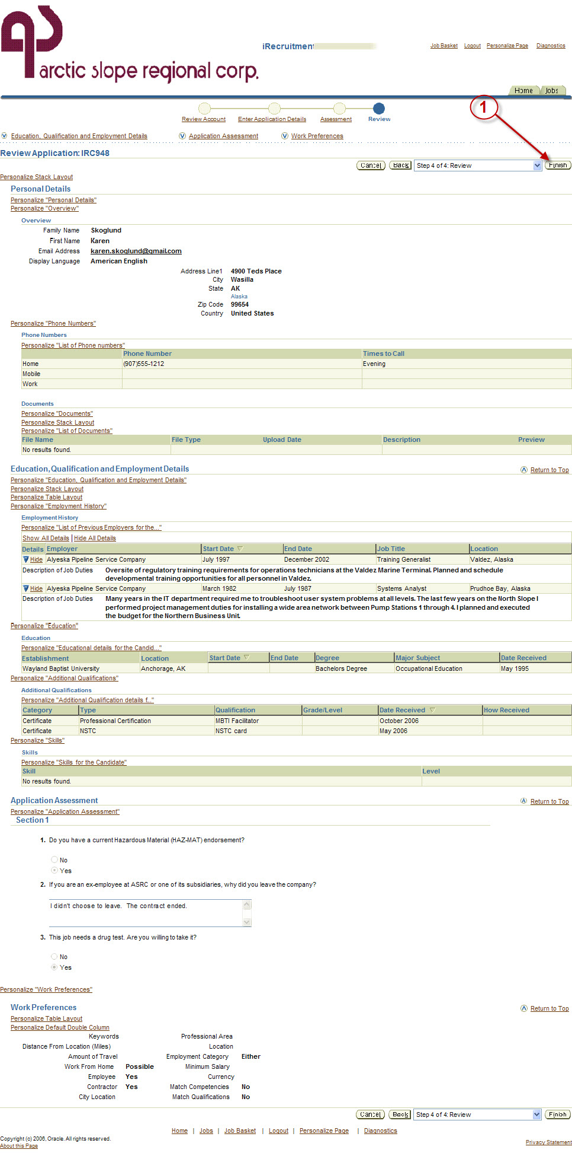

Figure 6.7
A confirmation message will appear as shown in Figure 6.8, arrow 1. Click on the Home tab to see the job listed in the bottom part of the home screen.
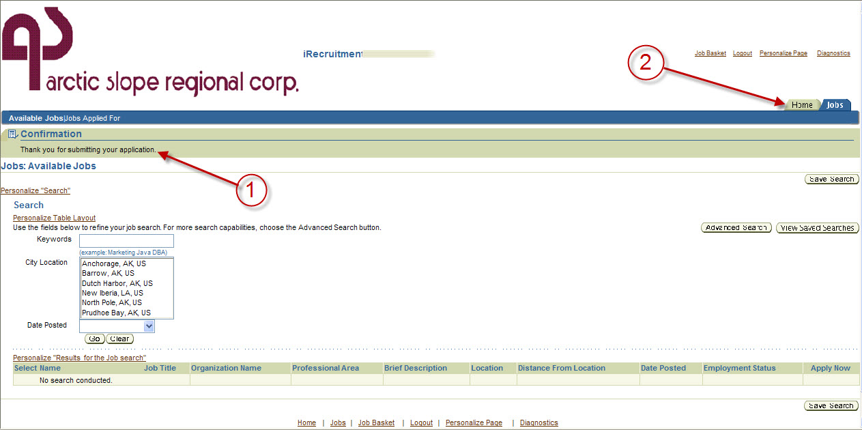
Figure 6.8

Getting Help
If you are a shareholder and have questions about the recruiting process or the iRecruitment system, please contact your local Village Representative or the Shareholder Hire and Career Development department.
If you are an ASRC employee, please contact the recruiter or HR representative assigned to your business group.
If you need further assistance or experiencing problems with the system, please call the ASRC Helpdesk at:

Internal ASRC phone network: x76900
External to ASRC phone network: 339-6900

________________________________________ ___________________________
Name Phone

________________________________________ ___________________________
Name Phone

Glossary

Candidate: Anyone in iRecruitment’s profile data base. Candidates are potential recruits for filling a job vacancy.
Competency: A competency is a skill or talent, specialized knowledge, or ability to accomplish a specific task. Competencies are used in iRecruitment to allow hiring managers and recruiters to designate what is needed to be qualified for hire in a particular vacancy. Potential candidates use competencies to show what skills and talents they have that qualify them for hire to a particular job vacancy.
Hiring Manager: The Hiring Manager is a term iRecruitment uses to refer to the person that the job vacancy will report to, regardless of their management position or actual title.
Profile: This is a collection of information that iRecruitment keeps on a person such as work history, education, certifications, and competencies, similar to what would be on a resume. The profile can only be maintained by that individual, and it stays in the system data base.
Vacancy: A vacancy is an open job position in iRecruitment. Creating a job vacancy is how the recruiting process is started.

